Experiment 3

Design of Google Logo using GIMP:-

Step 1:- Select a square shape transparent layer

Step 2:- Draw a circle inside the layer and set the color of circle white .

Step 3:-create a another transparent layer and this time create a small circle in the center of the bigger circle and color it blue as google chrome’s logo originally have .

Step 4:- Again create a transparent layer and this time use free select tool to select the area which we will paint red.

Step 5:- Use bucket filter to fill the section to the red color.

Step 6:- Now again create a transparent layer and use free select tool to select the aera for green color and by the help of bucket filter fill the section by grenn color.

Step7:- Again create a transparent layer and sue the same tools for yellow section to select and color the section into yellow.

Step 8:- Now at the end remove the background color and google chrom logo is ready.

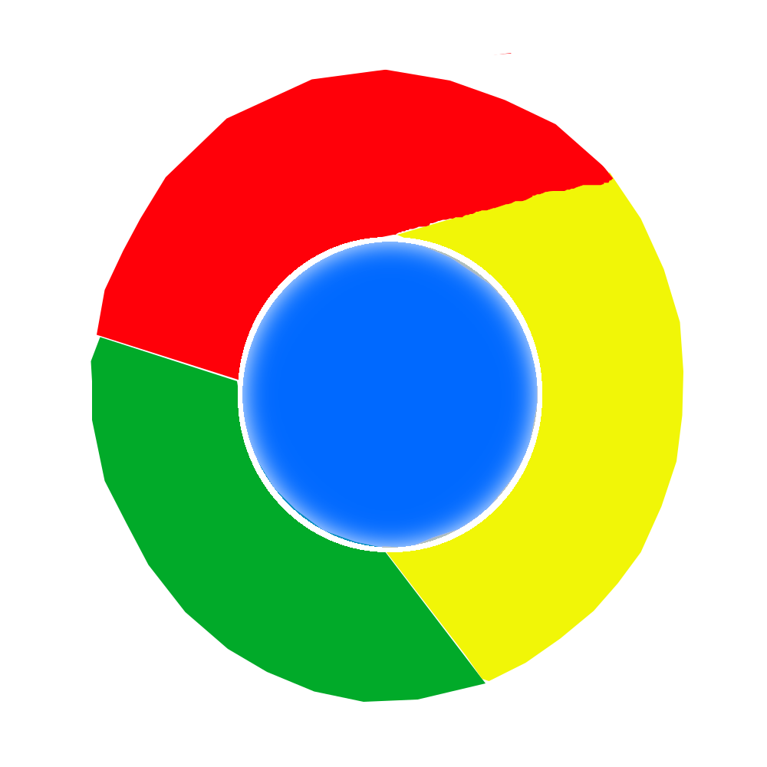

Final chrome logo design in GIMP